Given a binary tree with the following rules:

1. root.val == 0
2. If treeNode.val == x and treeNode.left != null, then treeNode.left.val == 2 * x + 1
3. If treeNode.val == x and treeNode.right != null, then treeNode.right.val == 2 * x + 2

Now the binary tree is contaminated, which means all treeNode.val have been changed to -1.

You need to first recover the binary tree and then implement the FindElements class:

* FindElements(TreeNode* root) Initializes the object with a contamined binary tree, you need to recover it first.
* bool find(int target) Return if the target value exists in the recovered binary tree.

**Example 1:**

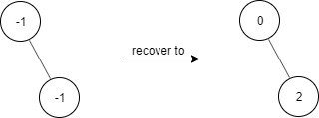

**Input**

["FindElements","find","find"]

[[[-1,null,-1]],[1],[2]]

**Output**

[null,false,true]

**Explanation**

FindElements findElements = new FindElements([-1,null,-1]);

findElements.find(1); // return False

findElements.find(2); // return True

**Example 2:**

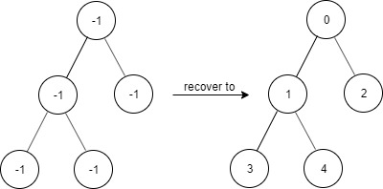

**Input**

["FindElements","find","find","find"]

[[[-1,-1,-1,-1,-1]],[1],[3],[5]]

**Output**

[null,true,true,false]

**Explanation**

FindElements findElements = new FindElements([-1,-1,-1,-1,-1]);

findElements.find(1); // return True

findElements.find(3); // return True

findElements.find(5); // return False

**Example 3:**

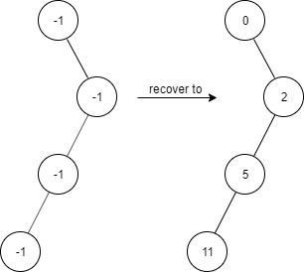

**Input**

["FindElements","find","find","find","find"]

[[[-1,null,-1,-1,null,-1]],[2],[3],[4],[5]]

**Output**

[null,true,false,false,true]

**Explanation**

FindElements findElements = new FindElements([-1,null,-1,-1,null,-1]);

findElements.find(2); // return True

findElements.find(3); // return False

findElements.find(4); // return False

findElements.find(5); // return True

**Constraints:**

* TreeNode.val == -1
* The height of the binary tree is less than or equal to 20
* The total number of nodes is between [1, 10^4]
* Total calls of find() is between [1, 10^4]
* 0 <= target <= 10^6